Schema to be Created
CREATE TABLE Customers (
CustomerID NUMBER PRIMARY KEY,
Name VARCHAR2(100),
DOB DATE,
Balance NUMBER,
LastModified DATE
);

CREATE TABLE Accounts (
AccountID NUMBER PRIMARY KEY,
CustomerID NUMBER,
AccountType VARCHAR2(20),
Balance NUMBER,
LastModified DATE,
FOREIGN KEY (CustomerID) REFERENCES Customers(CustomerID)
);

CREATE TABLE Transactions (
TransactionID NUMBER PRIMARY KEY,
AccountID NUMBER,
TransactionDate DATE,
Amount NUMBER,
TransactionType VARCHAR2(10),
FOREIGN KEY (AccountID) REFERENCES Accounts(AccountID)
);
CREATE TABLE Loans (
LoanID NUMBER PRIMARY KEY,
CustomerID NUMBER,
LoanAmount NUMBER,
InterestRate NUMBER,
StartDate DATE,
EndDate DATE,
FOREIGN KEY (CustomerID) REFERENCES Customers(CustomerID)
);

CREATE TABLE Employees (
EmployeeID NUMBER PRIMARY KEY,
Name VARCHAR2(100),
Position VARCHAR2(50),
Salary NUMBER,
Department VARCHAR2(50),
HireDate DATE
);

Example Scripts for Sample Data Insertion

INSERT INTO Customers (CustomerID, Name, DOB, Balance, LastModified)
VALUES (1, 'John Doe', TO_DATE('1985-05-15', 'YYYY-MM-DD'), 1000, SYSDATE);

INSERT INTO Customers (CustomerID, Name, DOB, Balance, LastModified)
VALUES (2, 'Jane Smith', TO_DATE('1990-07-20', 'YYYY-MM-DD'), 1500, SYSDATE);

INSERT INTO Accounts (AccountID, CustomerID, AccountType, Balance, LastModified)
VALUES (1, 1, 'Savings', 1000, SYSDATE);

INSERT INTO Accounts (AccountID, CustomerID, AccountType, Balance, LastModified)
VALUES (2, 2, 'Checking', 1500, SYSDATE);

INSERT INTO Transactions (TransactionID, AccountID, TransactionDate, Amount, TransactionType)
VALUES (1, 1, SYSDATE, 200, 'Deposit');

INSERT INTO Transactions (TransactionID, AccountID, TransactionDate, Amount, TransactionType)
VALUES (2, 2, SYSDATE, 300, 'Withdrawal');

INSERT INTO Loans (LoanID, CustomerID, LoanAmount, InterestRate, StartDate, EndDate)
VALUES (1, 1, 5000, 5, SYSDATE, ADD_MONTHS(SYSDATE, 60));

INSERT INTO Employees (EmployeeID, Name, Position, Salary, Department, HireDate)
VALUES (1, 'Alice Johnson', 'Manager', 70000, 'HR', TO_DATE('2015-06-15', 'YYYY-MM-DD'));

INSERT INTO Employees (EmployeeID, Name, Position, Salary, Department, HireDate)
VALUES (2, 'Bob Brown', 'Developer', 60000, 'IT', TO_DATE('2017-03-20', 'YYYY-MM-DD'));

Exercise 1: Control Structures

Scenario 1: The bank wants to apply a discount to loan interest rates for customers above 60 years old.
  - Question: Write a PL/SQL block that loops through all customers, checks their age, and if they are above 60, apply a 1% discount to their current loan interest rates.
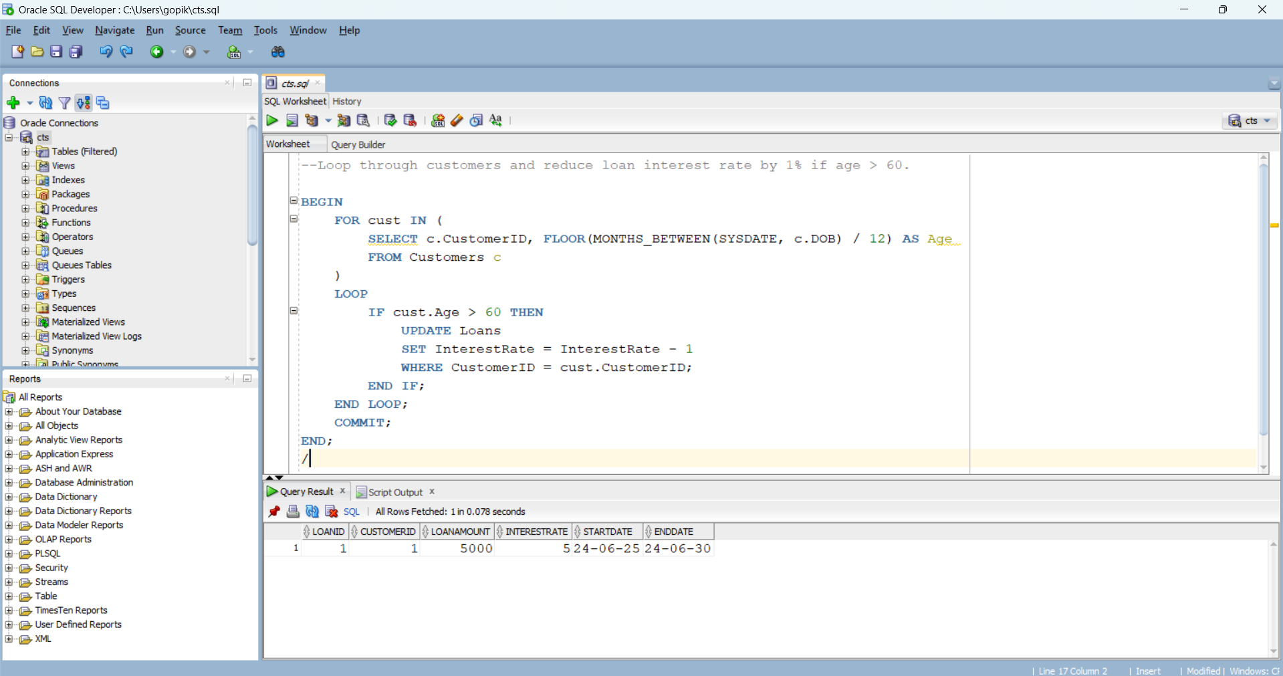
Scenario 2: A customer can be promoted to VIP status based on their balance.
  - Question: Write a PL/SQL block that iterates through all customers and sets a flag IsVIP to TRUE for those with a balance over $10,000.
Scenario 3: The bank wants to send reminders to customers whose loans are due within the next 30 days.
  - Question: Write a PL/SQL block that fetches all loans due in the next 30 days and prints a reminder message for each customer.

